Practical - 1
Practical Title: Project Initiation, Requirement Analysis, Sitemap, Wireframe, and GitHub Setup

Initiate the semester-long StudentHub portal by identifying the problem scope, user roles, key modules, navigation flow, and minimum 10 pages. Create a sitemap, low-fidelity wireframe, project folder structure, README file, and GitHub repository.

1. What is URL and parts of URL?
A URL (Uniform Resource Locator) is the address used to access a resource on the internet. Its main parts include protocol (HTTPS), domain name, port, path, query, and fragment.
Reference Link: URL (Uniform Resource Locator) - GeeksforGeeks

2. How does HTML file processed in web browser?
The browser reads the HTML file, parses its elements and creates the DOM (Document Object Model). It then applies CSS, executes JavaScript if present, and renders the final webpage on the screen.
Reference Link: URL (Uniform Resource Locator) - GeeksforGeeks

3. How will page navigation flow managed among all HTML pages?
Page navigation is managed using the HTML <a> tag with the href attribute. Each navigation link points to another HTML file, allowing users to move between pages such as Home, Dashboard, Profile, and Contact.
Reference Link : URL (Uniform Resource Locator) - GeeksforGeeks
4. How will GitHub commits be maintained after each practical?
After completing each practical, changes can be added using git add, saved with a meaningful git commit -m "message", and uploaded using git push origin main. This maintains a history of changes for each practical.
Reference Link : URL (Uniform Resource Locator) - GeeksforGeeks

Implementation/ Output/Result

My learning codes: https://drive.google.com/file/d/1CPP3uUq3gdKZxC3pFB7iheZVU7FCImSx/view?usp=drive_link

Evidence of Work (Screenshots)
SiteMap:
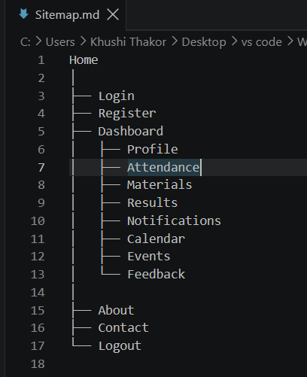
Description:
A sitemap is a structured diagram or list that shows all the pages of a website and how they are connected. It helps users and developers understand the website’s navigation and page flow.

Requirement Analysis:
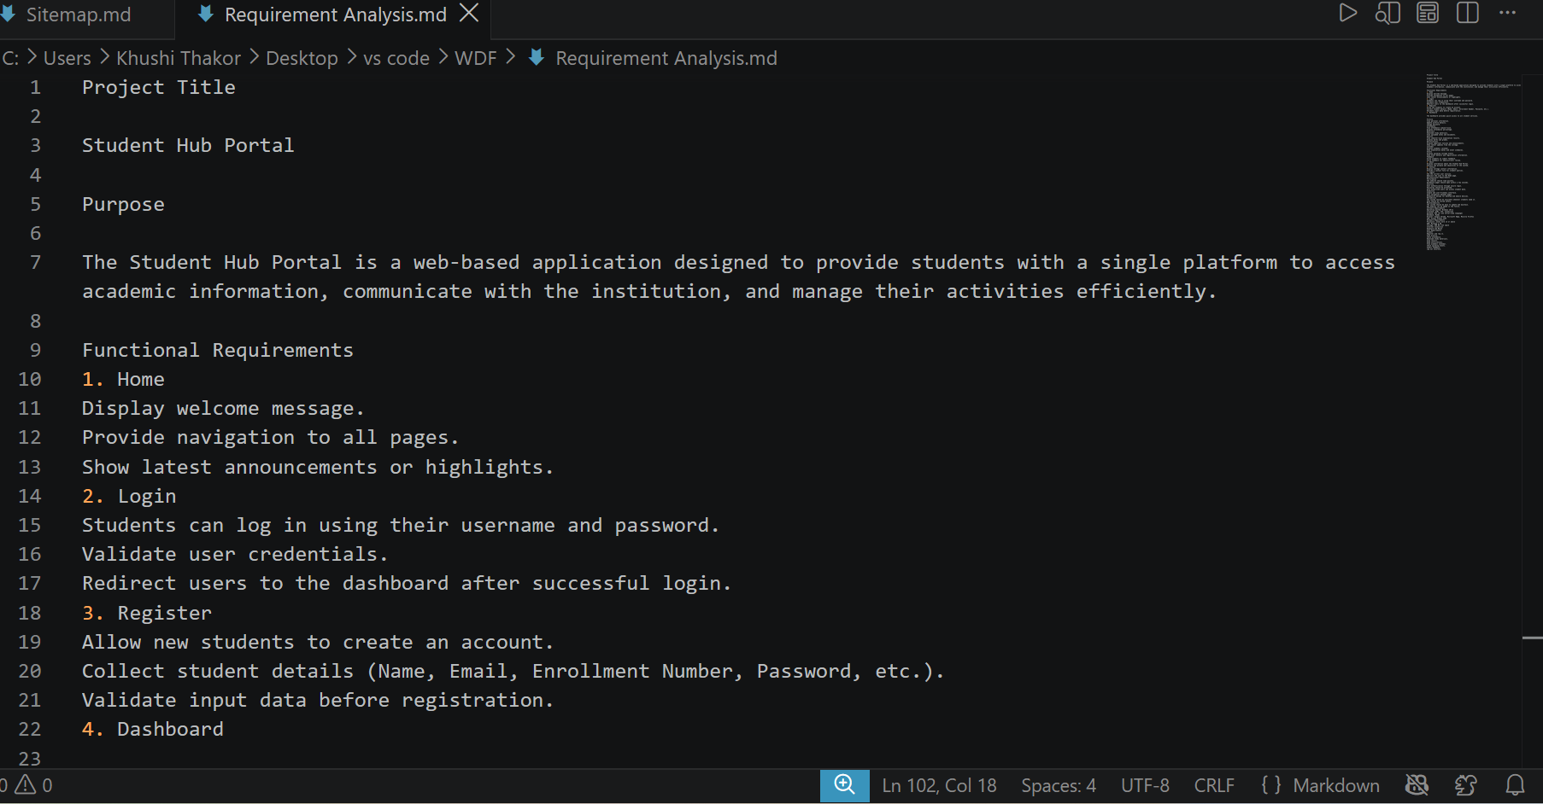

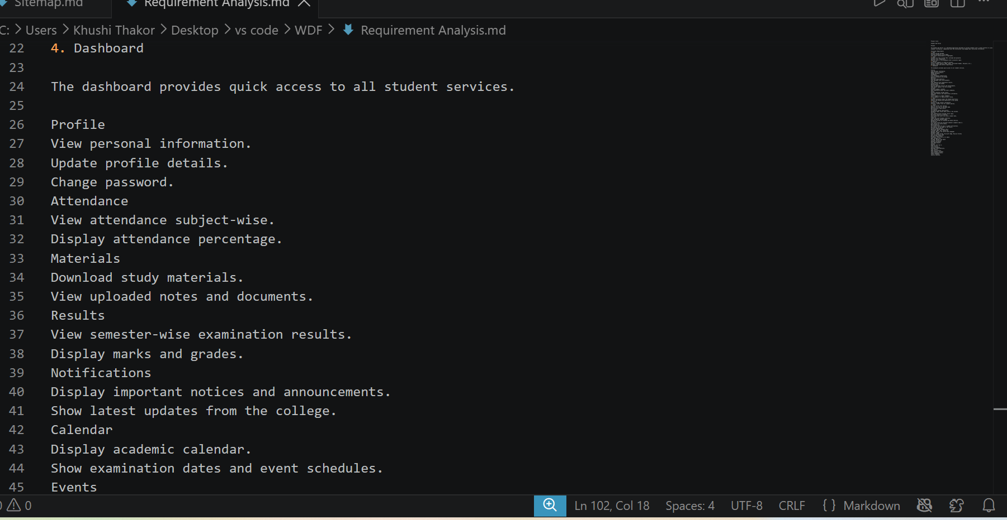
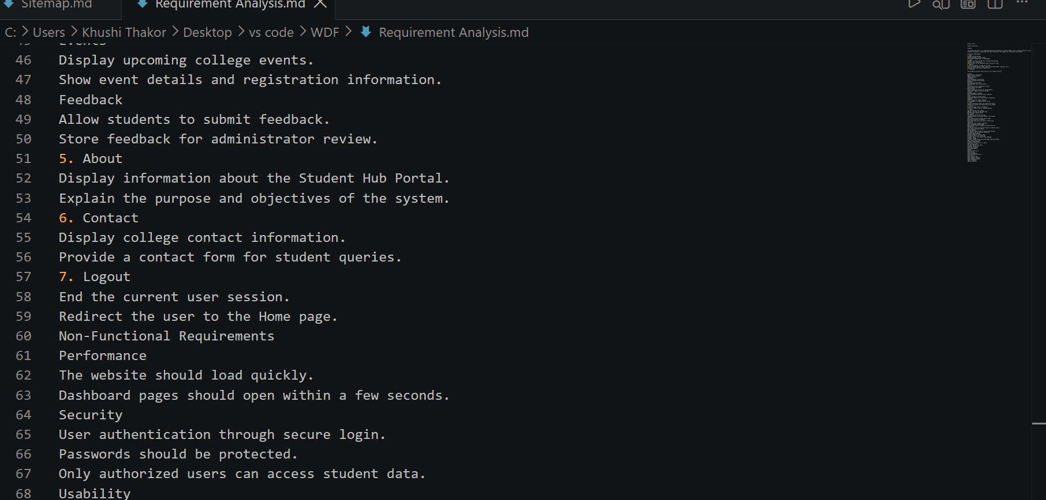

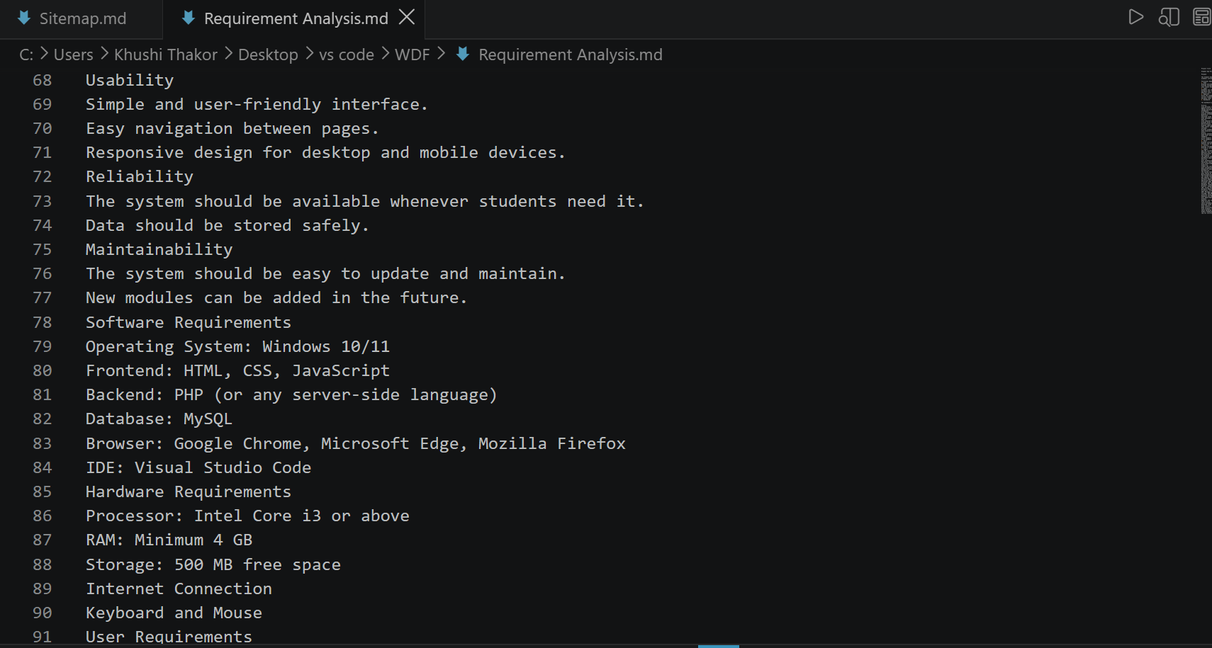
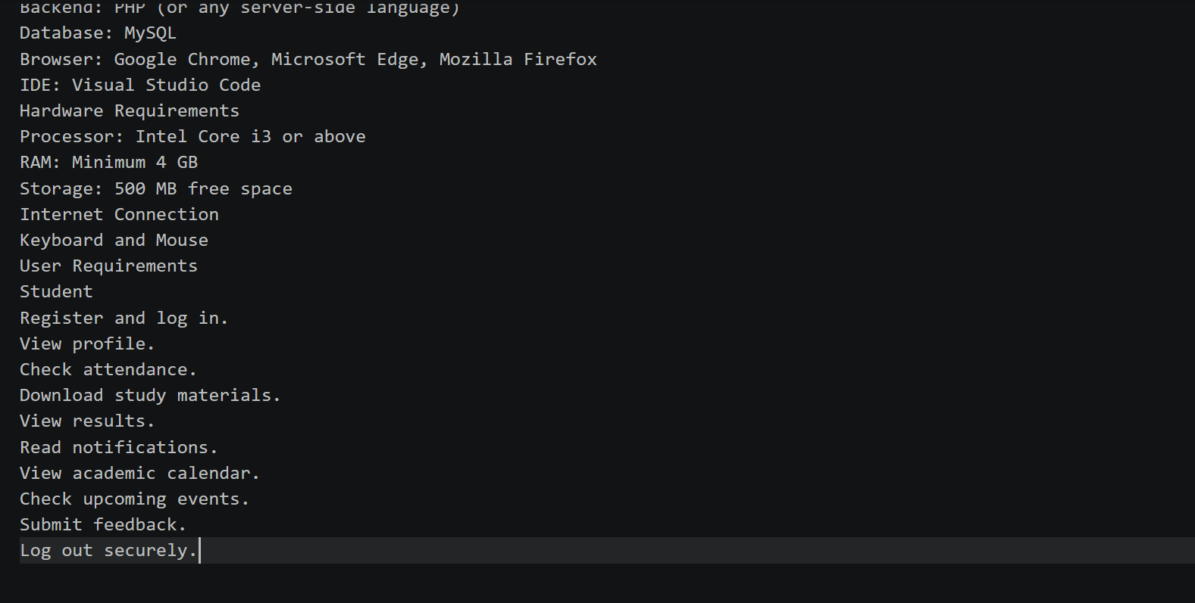
Description:
Requirement analysis is the process of identifying and documenting what the website needs to provide. It defines the required features, users, pages, and functionality before development begins.
Wireframe:
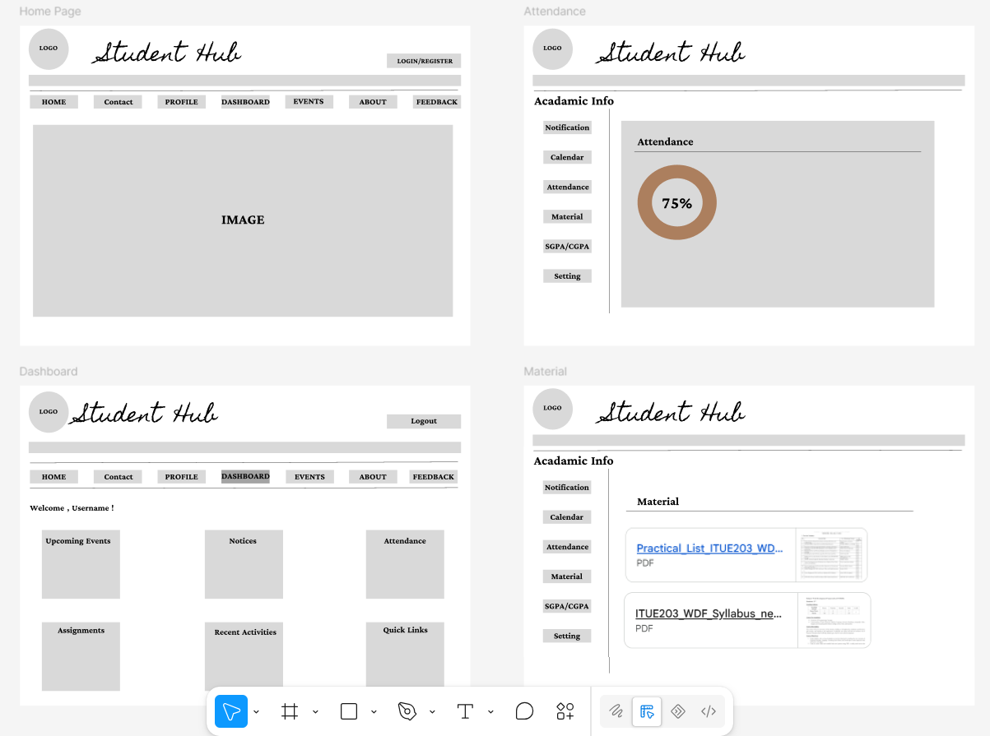
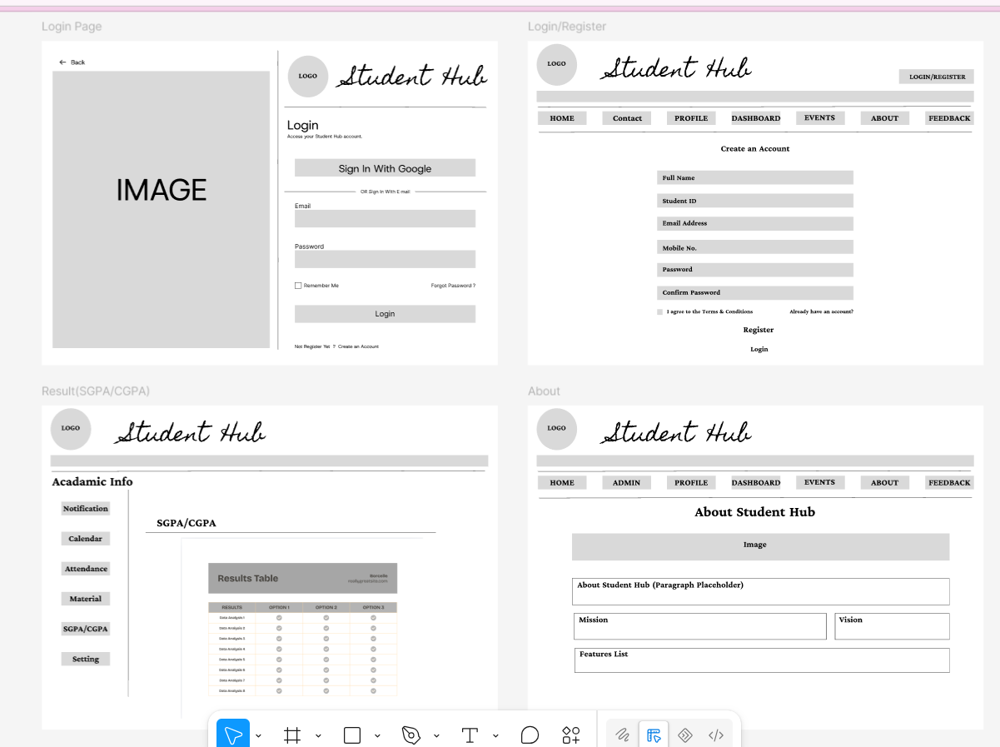
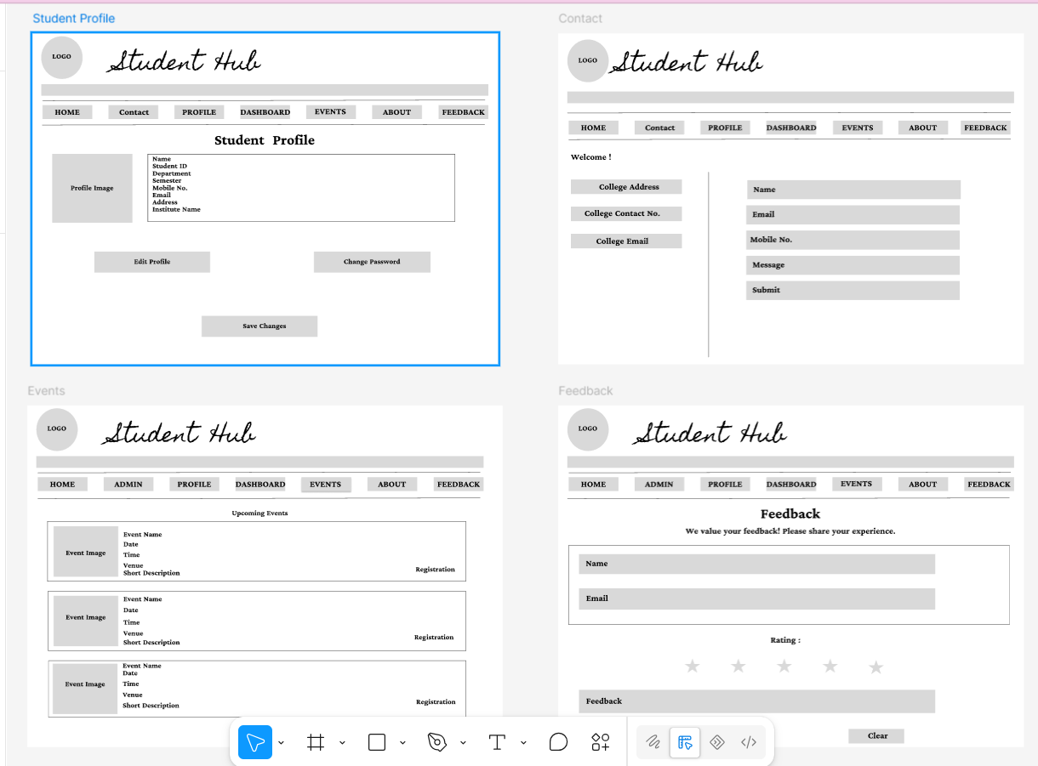
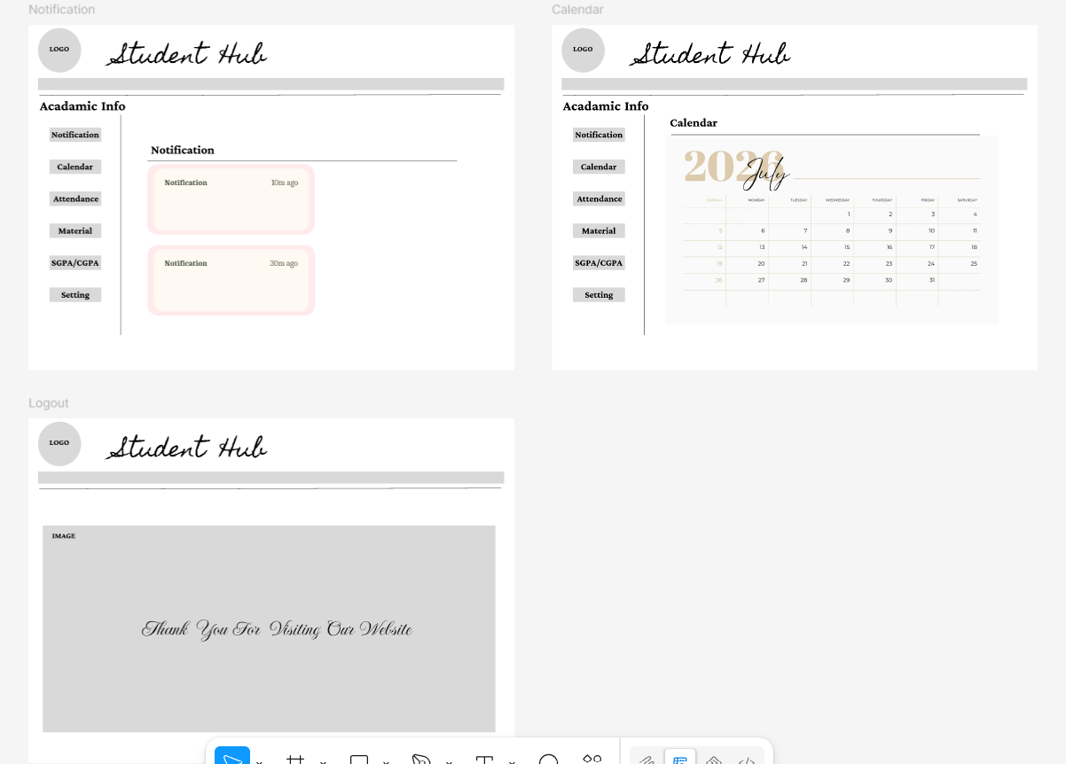

GitHub Repository Link:
Khushi-Thakor2007/Student-Hub-Portal

Challenges Faced:
The main problem I faced while creating the wireframe was understanding and learning how to use the Figma tool effectively.

Learning Outcomes:

Students will be able to analyze requirements and prepare a structured project foundation before implementation.

Faculty Remarks:

